Arlo - The Robot You've Always Wanted

# Preface

My robot has multiple microcontrollers performing various tasks, but the overall operation of the robot is controlled by a real Windows 8 Tablet Computer. The tablet’s small size lets it serve as the robot’s head and face and having a full featured computer in control makes it far easier to create exciting robotic behaviors.

ou can view Arlo’s **YouTube** videos by searching YouTube for *Arlo: The Robot You’ve Always Wanted* (Parts 1 and 2)

# Chapter 1 – What to Expect

The robot’s name is Arlo, after the **Parallax** **base** used to give him mobility. Many of the Arlo’s navigational sensors are located in the base, but others are mounted on the turret below the head.

The robot’s arms are from EZ-robot. They are relatively small so they cannot reach the floor or even a table.

## Arlo’s Computer

Arlo’s many capabilities means he needs far more computing power than the single microcontroller often used to control hobby robots.

# Chapter 2 - The Physical Construction

The Parallax (www.Parallax.com) Arlo System (shown in Figure 2.2) was chosen because it is a highquality, rigid platform with strong motors with integrated wheel encoders. The base is 18 inches in diameter, large enough for stability, yet easily able to pass through standard doorways.

<https://www.parallax.com/product/arlo-complete-robot-system/>

## Ping Sensors

Before you fully assemble the base you will need to mount six Ping ultrasonic distance measuring sensors (also from Parallax) to the bottom of the top plate.

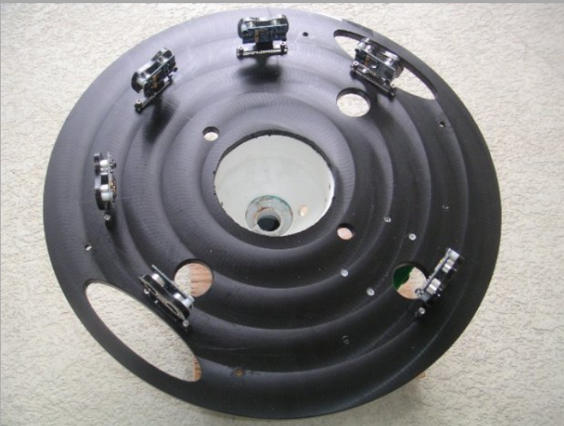

Figure 2.4: Six Ping sensors are mounted the bottom of the top plate.

## Line Sensors

The robot can utilize three line sensors if you want the robot to handle projects such as following a line on the floor.

## Structural Components

Only two structural additions are needed to give the Arlo base a more human-like appearance. They are shown in Figure 2.7. The main body support is made from a two-foot piece of 4-inch PVC pipe.

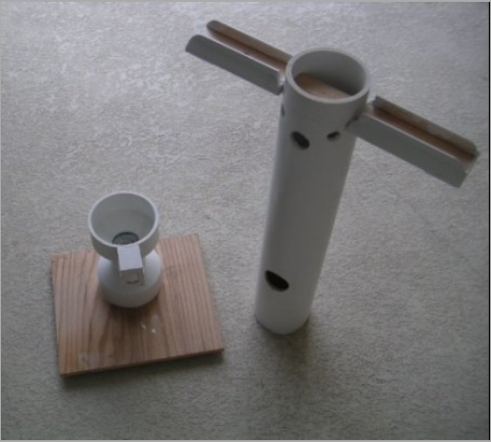

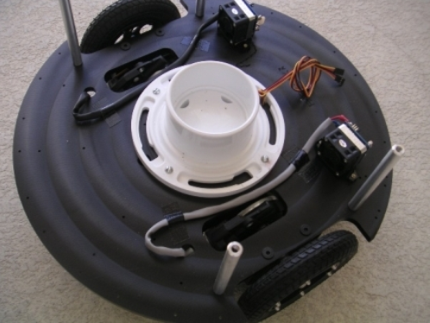

Figure 2.11: The Parallax motor controllers mount to the top of the bottom plate. The second toliet flange provides additional support for Arlo’s body.

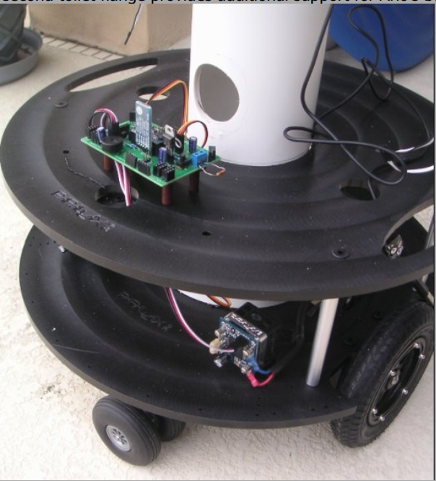

Figure 2.12: Things are starting to take shape.

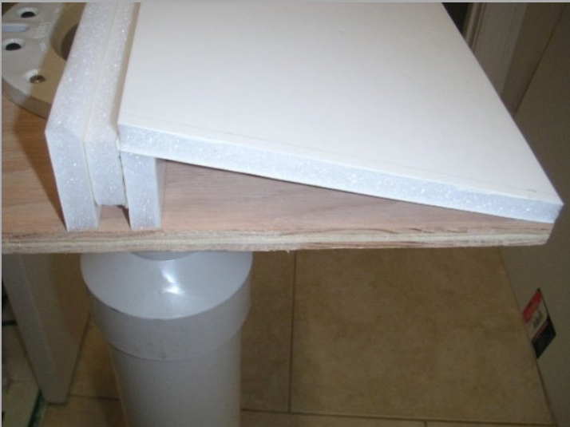

Figure 2.15: The entire PC, including keyboard, sits here.

### Chapter 3 - An Overview of the Electronics

## The RobotBASIC Robot Operating System

In order to simplify the sensor interfacing and decrease the overall programming complexity, the PC will connect with the RobotBASIC Robot Operating System (RROS) PCB mounted on the upper deck at the rear of the robot as shown in Figure 3.4.

The sensors supported by the RROS are sufficient for many projects but a home-based robot like Arlo should be able to navigate autonomously, so extra sensors are always valuable. As such, an x-y turret mounted under the head (see Figure 3.5) will add additional capability for increased reliability in complex situations. The turret supports a webcam, an **IR ranging sensor**, a **Maxbotix ranging sensor** (chosen because it has an analog output), and the **beacon sensor** mentioned earlier.

The turret’s servomotors will be controlled by a **Pololu Maestro 24 Servo Controller** (Figure 3.6) mounted just below the shoulders on the back of the 4” PVC pipe, as shown in Figure 3.7. This unit was chosen because it can read analog and digital signals (from sensors) in addition to controlling servomotors. By using Pololu’s largest servo controller (24 I/O lines) there are just enough pins to control the six servos in each arm, the two turret servos, read the analog signals from the turret IR (or laser) and the ultrasonic ranger, and monitor the digital outputs from the 4 sensors in each gripper. This is a lot of power from the tiny board. Multiple controllers can also be daisy chained, making it easy for advanced users to add additional servos or sensors.

<https://www.pololu.com/product/1356>

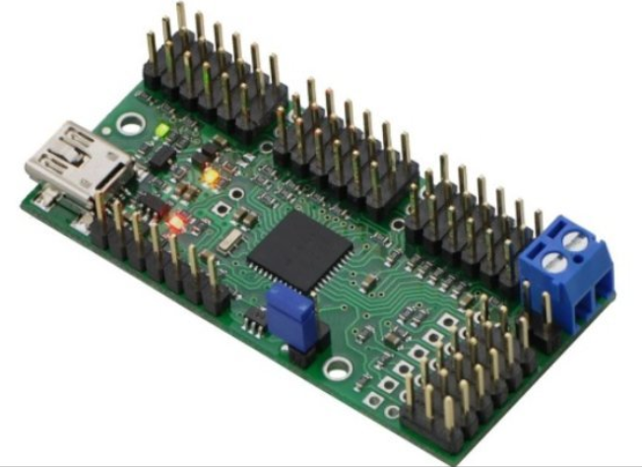

Figure 3.6: The Pololu Servo Controller handles the Arms.

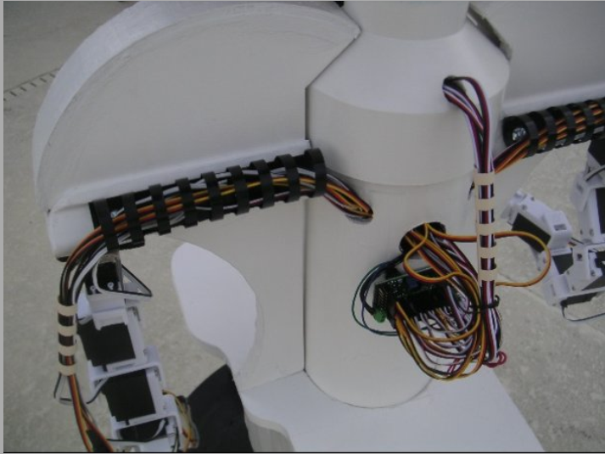

Figure 3.7: The PVC pipe is handy for routing wires.

The third IR sensor points across the hand opening so it can detect when an object is actually within the gripper’s grasp area. The final sensor is a snap-action switch that indicates when the hand actually closes on the object. This not only ensures that the hand is closed properly regardless of the object’s size, it also allows the gripper to identify objects by their relative diameters (since the robot can determine the diameter from how far the hand must close to activate the switch).

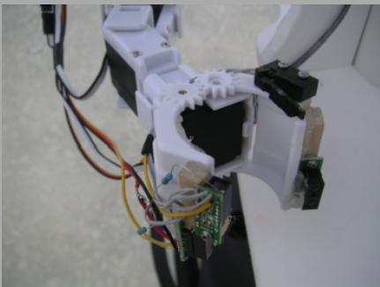

Figure 3.8: Additional sensors are added to the grippers.

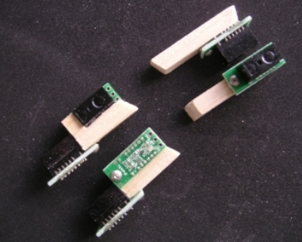

Figure 3.9: Each sensor has custom mountings.